**System Design**

**Use Case Diagrams:**

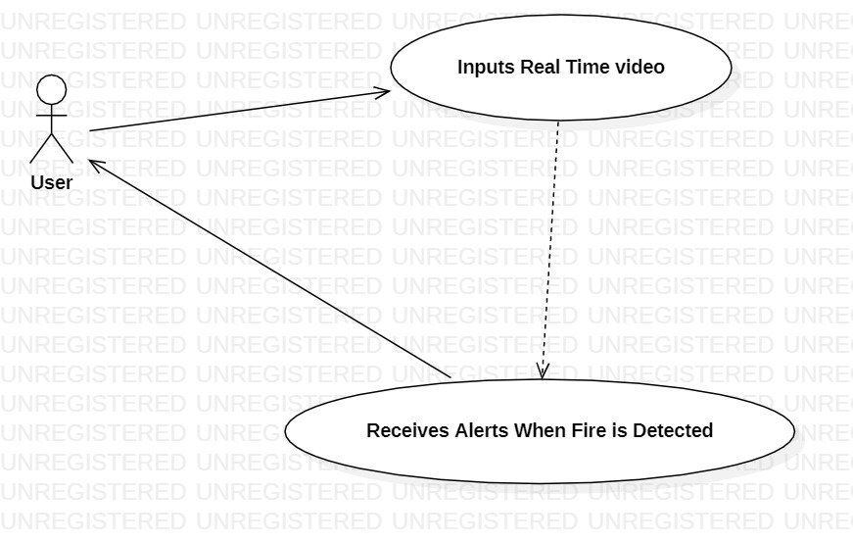

**Fig: Use Case Diagram for The User**

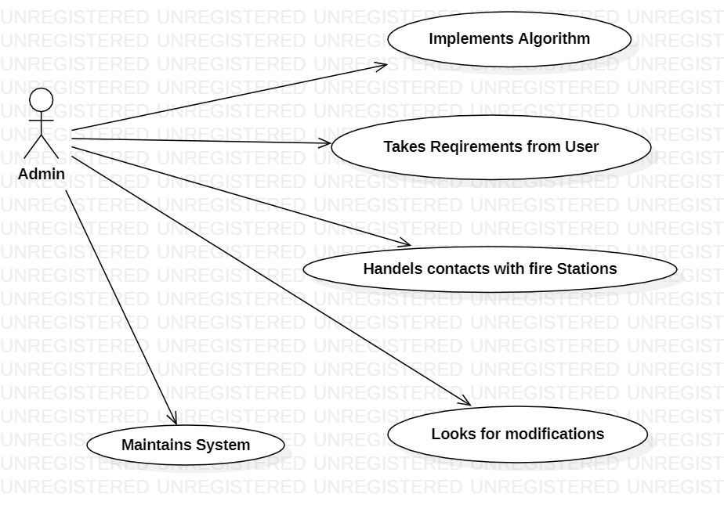

**Fig: Use Case Diagram for Admin**

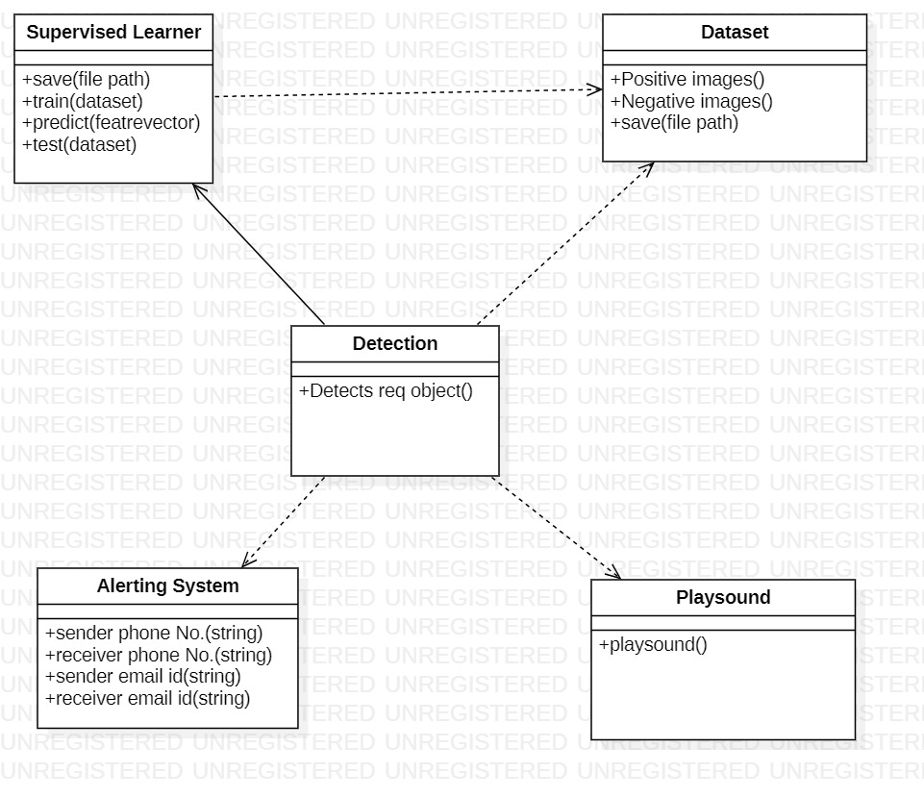

**Fig: Class Diagram For the System**

**Sequence Diagram:**

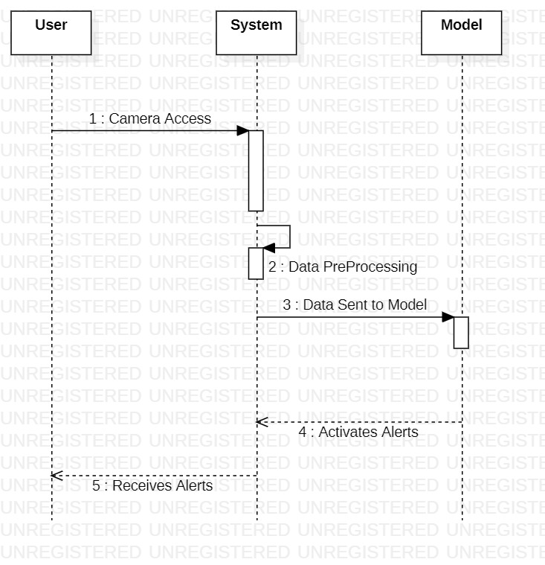

**Fig: Sequence Diagram of the System**